1. Design a page having suitable background colour and text colour with title “My First Web Page” using all the attributes of the Font tag.
2. 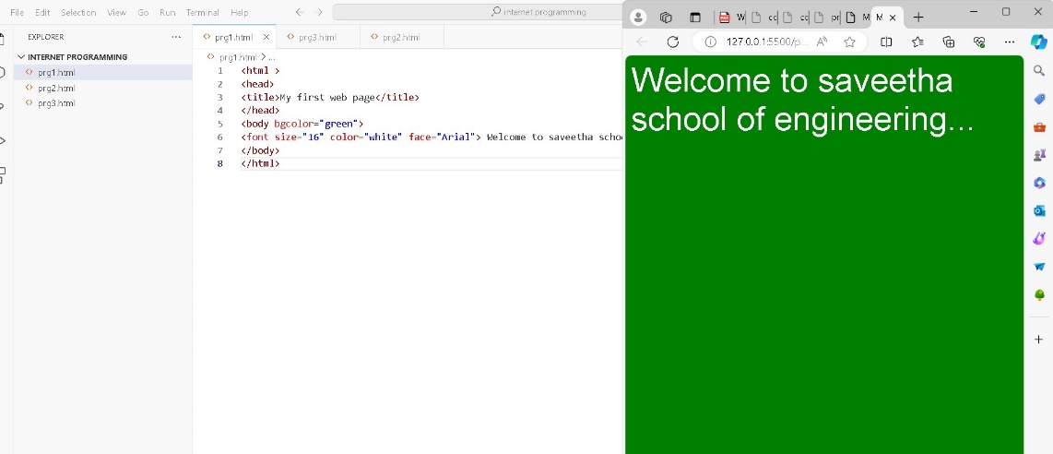

<html >

<head>

<title>My first web page</title>

</head>

<body bgcolor="green">

<font size="16" color="white" face="Arial"> Welcome to saveetha school of engineering...</font>

</body>

</html>

2.Create a HTML document giving details of your [Name, Age], [Address, Phone] and [Register Number, Class] aligned in proper order using alignment attributes of Paragraph tag.

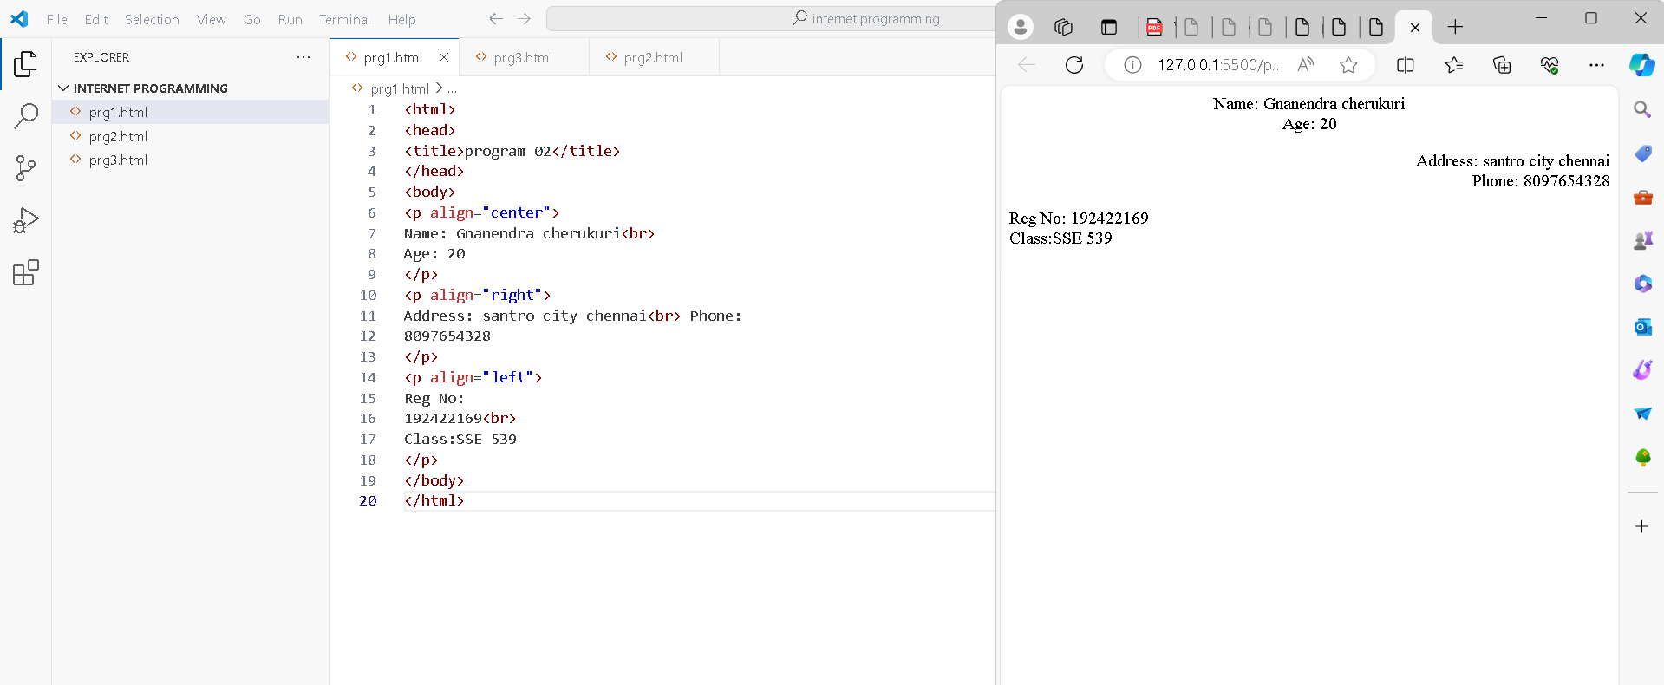

<html>

<head>

<title>program 02</title>

</head>

<body>

<p align="center">

Name: Gnanendra cherukuri<br>

Age: 20

</p>

<p align="right">

Address: santro city chennai<br> Phone:

8097654328

</p>

<p align="left">

Reg No:

192422169<br>

Class:SSE 539

</p>

</body>

</html>

3.Write HTML code to design a page containing some text in a paragraph by giving suitable heading style.

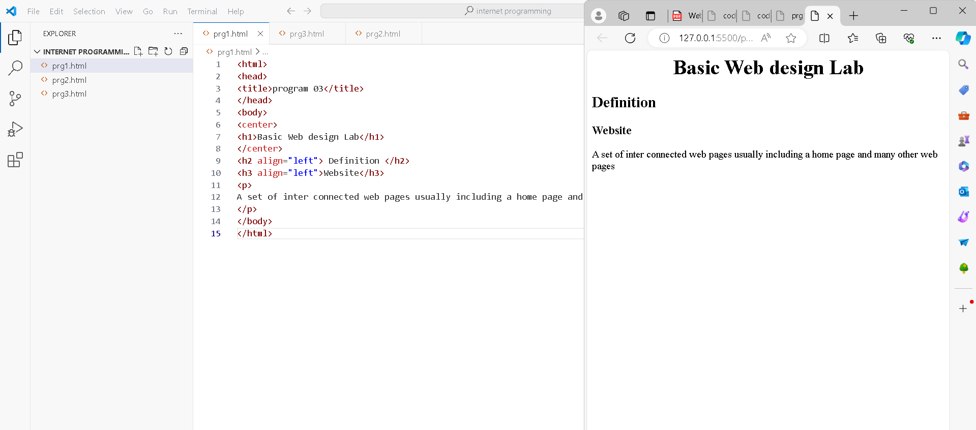

<html>

<head>

<title>program 03</title>

</head>

<body>

<center>

<h1>Basic Web design Lab</h1>

</center>

<h2 align="left"> Definition </h2>

<h3 align="left">Website</h3>

<p>

A set of inter connected web pages usually including a home page and many other web pages

</p>

</body>

</html>

4.Create a page to show different character formatting (B, I, U, SUB, SUP) tags. viz : log b m p = p logb m

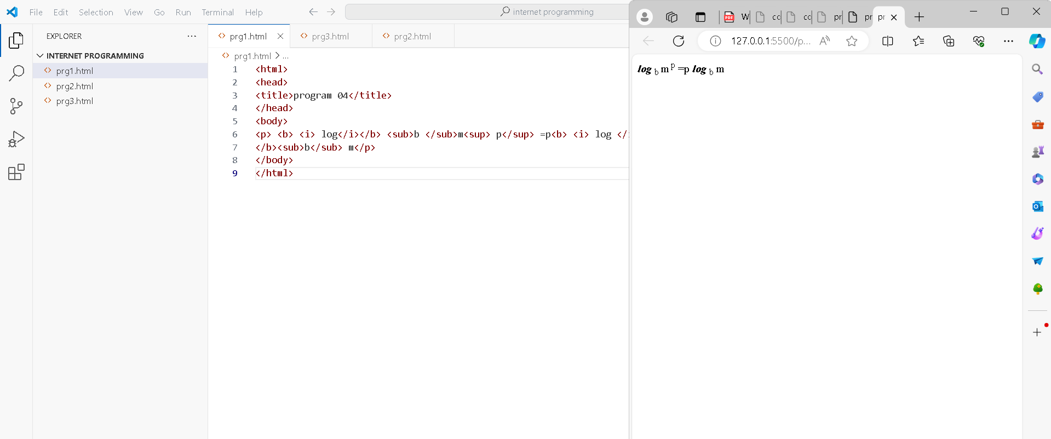

***log*** b m p =p ***log*** b m

5. Write HTML code to create a Web Page that contains an Image at its centre.

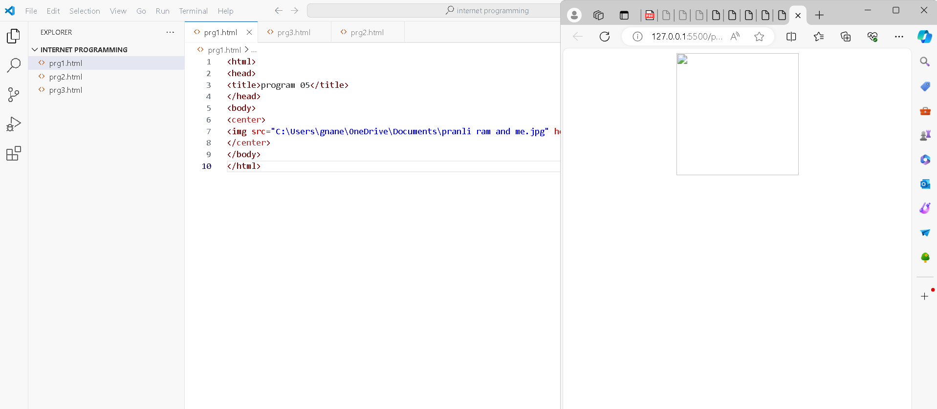

<html>

<head>

<title>program 05</title>

</head>

<body>

<center>

<img src="C:\Users\gnane\OneDrive\Documents\pranli ram and me.jpg" height="200" width="200" align="middle"/>

</center>

</body>

</html>

6.Create a web page with an appropriate image towards the left hand side of the page, when user clicks on the image another web page should open.

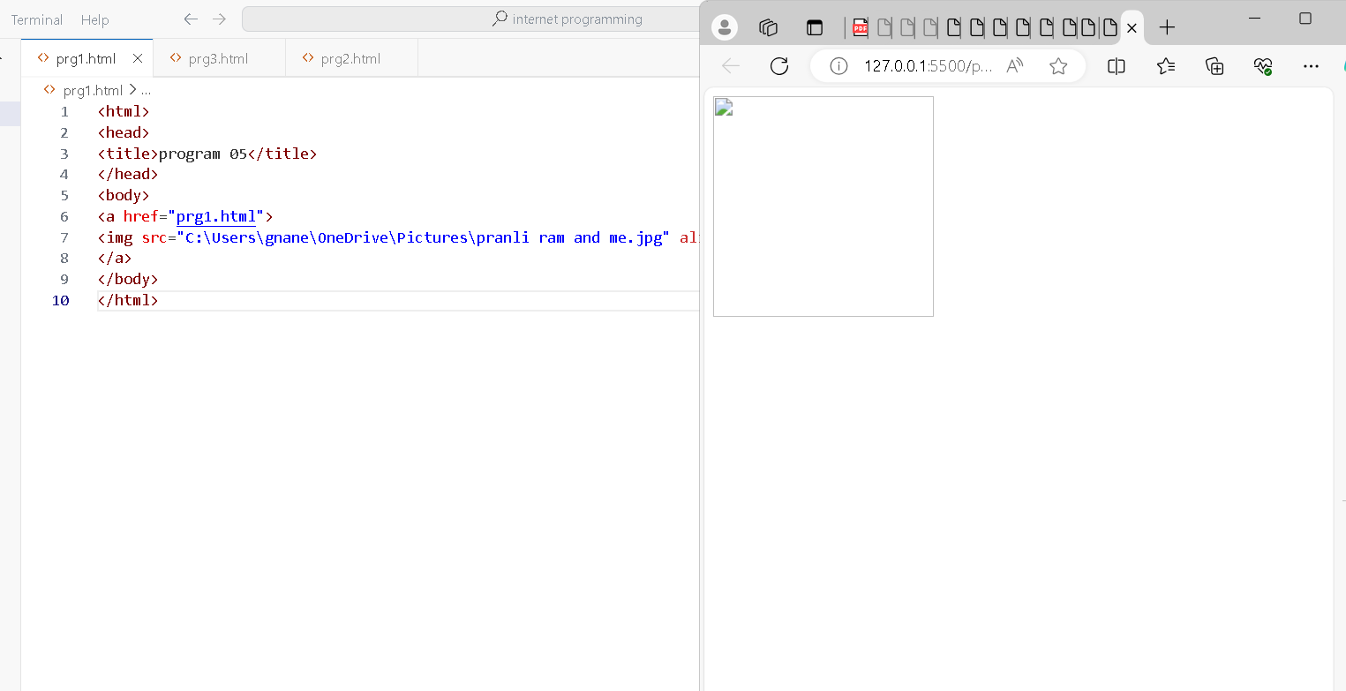

<html>

<head>

<title>program 05</title>

</head>

<body>

<a href="prg1.html">

<img src="C:\Users\gnane\OneDrive\Pictures\pranli ram and me.jpg" align="left" width="200" height="200"/>

</a>

</body>

</html>

7.Create web Pages using Anchor tag with its attributes for external links.

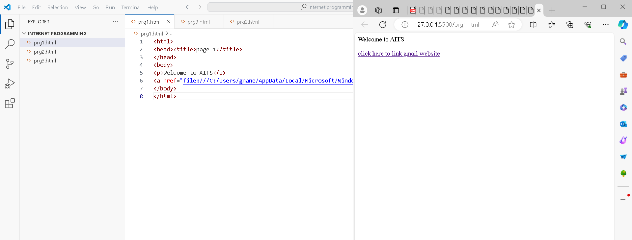

<html>

<head><title>page 1</title>

</head>

<body>

<p>Welcome to AITS</p>

<a href="file:///C:/Users/gnane/AppData/Local/Microsoft/Windows/INetCache/IE/UASE34V6/Web_Design_MANUAL-min_(1)[1].pdf">click here to link gmail website</a>

</body>

</html>

8. Create a web page for internal links; when the user clicks on different links on the web page it should go to the appropriate locations/sections in the same page.

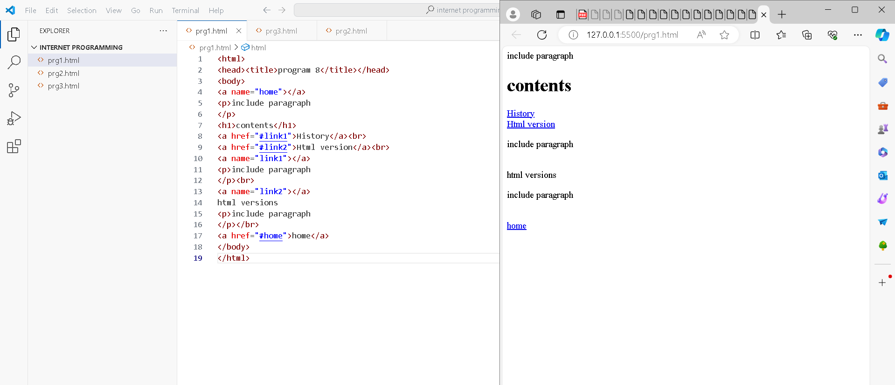

<html>

<head><title>program 8</title></head>

<body>

<a name="home"></a>

<p>include paragraph

</p>

<h1>contents</h1>

<a href="#link1">History</a><br>

<a href="#link2">Html version</a><br>

<a name="link1"></a>

<p>include paragraph

</p><br>

<a name="link2"></a>

html versions

<p>include paragraph

</p></br>

<a href="#home">home</a>

</body>

</html>

9. Write a HTML code to create a web page with pink color background and display moving message in red color.

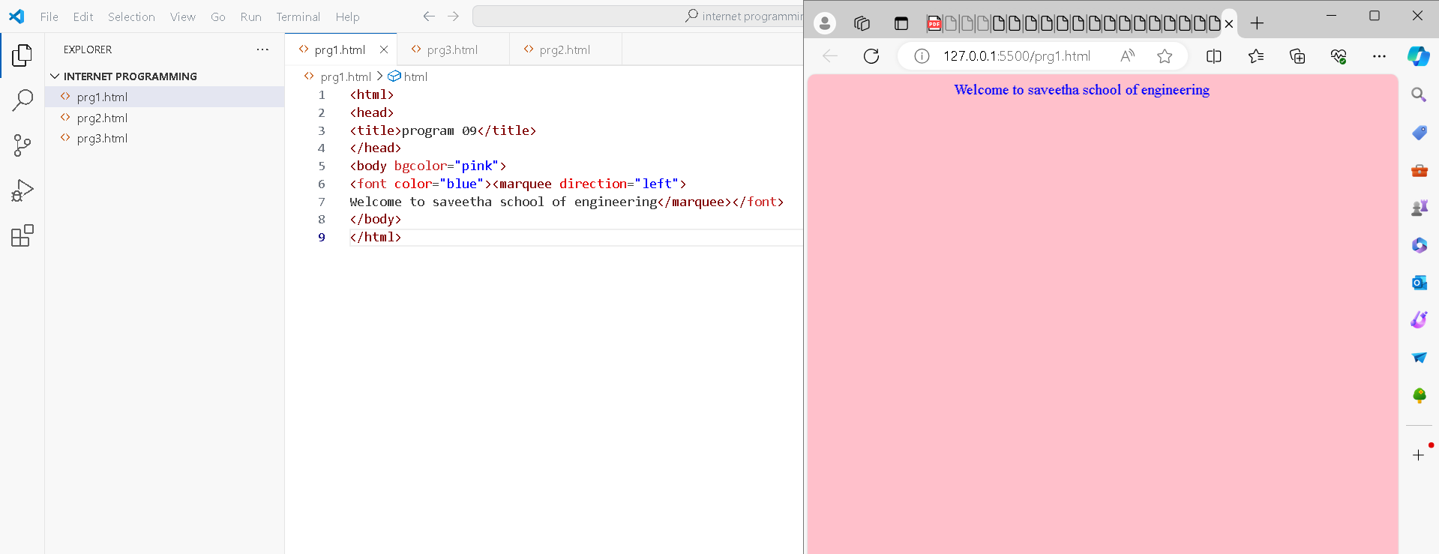

<html>

<head>

<title>program 09</title>

</head>

<body bgcolor="pink">

<font color="blue"><marquee direction="left">

Welcome to saveetha school of engineering</marquee></font>

</body>

</html>

10. Create a web page, showing an ordered list of all second semester courses

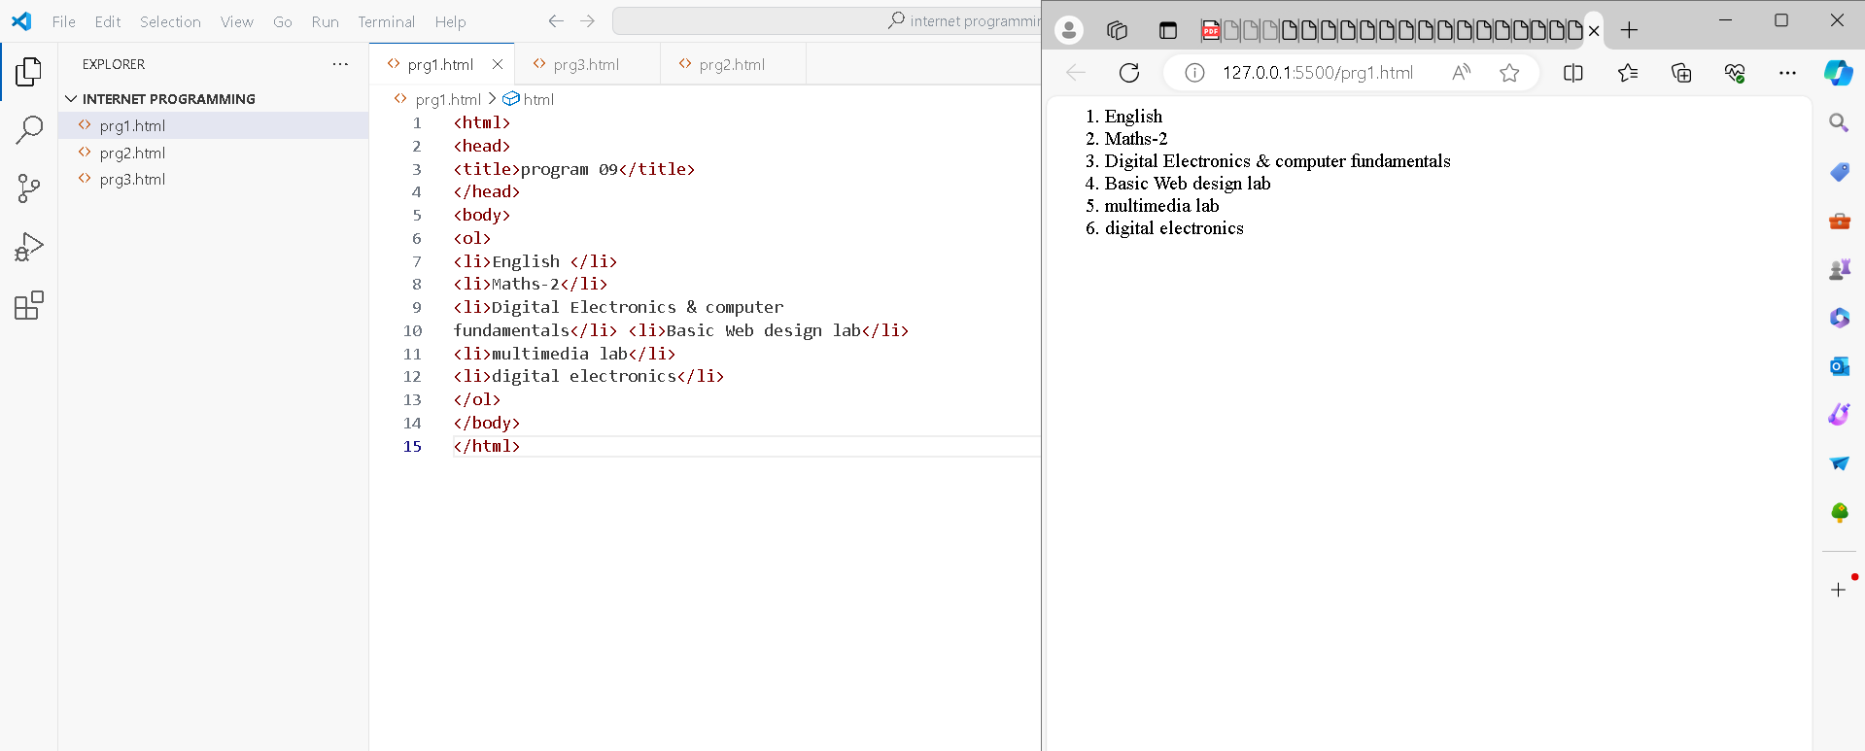

1. gyggEnglish
2. Maths-2
3. Digital Electronics & computer fundamentals
4. Basic Web design lab
5. multimedia lab
6. digital electronics

11.create a web page, showing an unordered list of names of all the Diploma Programmes (Branches) in your institution.

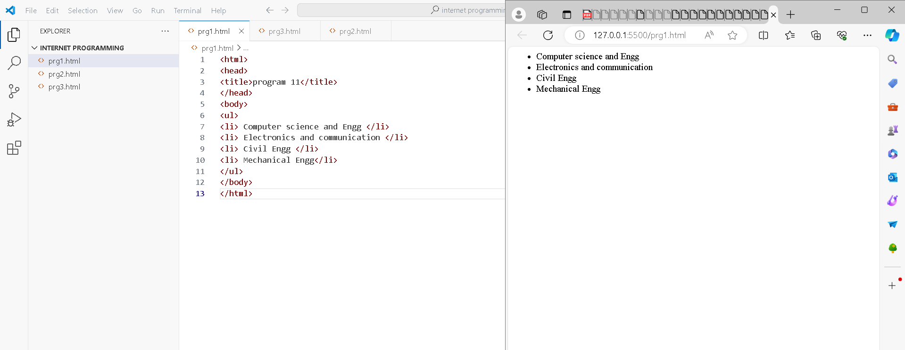

<html>

<head>

<title>program 11</title>

</head>

<body>

<ul>

<li> Computer science and Engg </li>

<li> Electronics and communication </li>

<li> Civil Engg </li>

<li> Mechanical Engg</li>

</ul>

</body>

</html>

12. Create a HTML document containing a nested list showing a content page of any book.

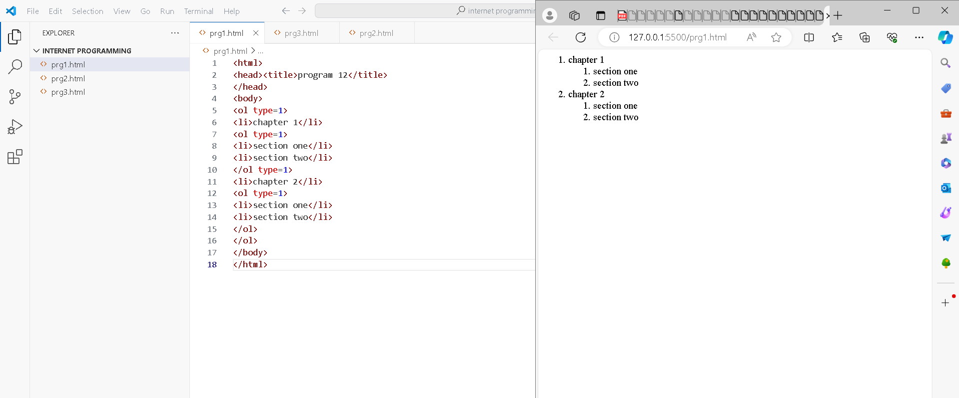

<html>

<head><title>program 12</title>

</head>

<body>

<ol type=1>

<li>chapter 1</li>

<ol type=1>

<li>section one</li>

<li>section two</li>

</ol type=1>

<li>chapter 2</li>

<ol type=1>

<li>section one</li>

<li>section two</li>

</ol>

</ol>

</body>

</html>

13. Create the following table in HTML with Dummy Data:

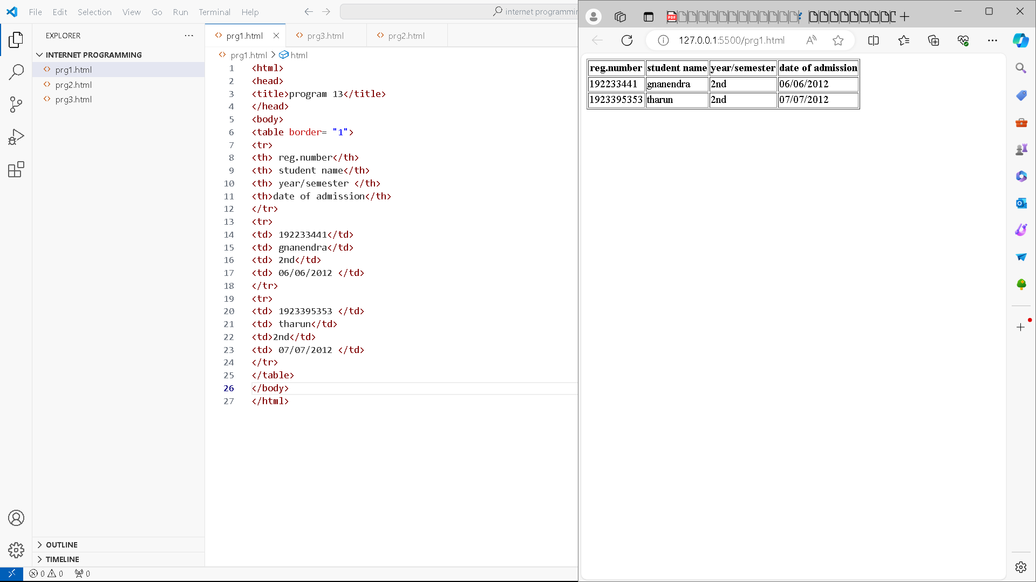

<html>

<head>

<title>program 13</title>

</head>

<body>

<table border= "1">

<tr>

<th> reg.number</th>

<th> student name</th>

<th> year/semester </th>

<th>date of admission</th>

</tr>

<tr>

<td> 192233441</td>

<td> gnanendra</td>

<td> 2nd</td>

<td> 06/06/2012 </td>

</tr>

<tr>

<td> 1923395353 </td>

<td> tharun</td>

<td>2nd</td>

<td> 07/07/2012 </td>

</tr>

</table>

</body>

</html>

14. Create a web page which divides the page in two equal frames and place the audio and video clips in frame-1 and frame-2 respectively.

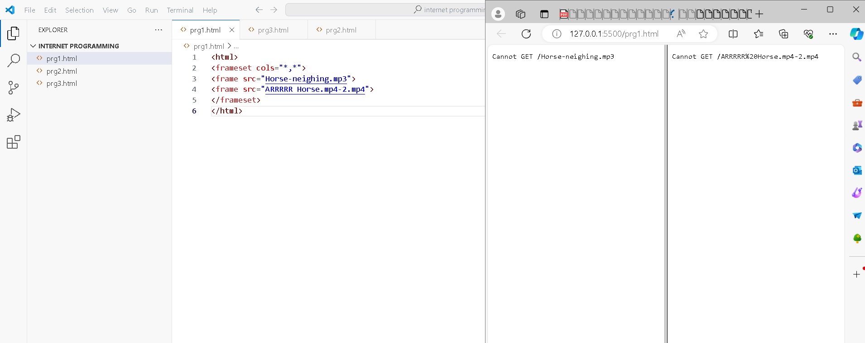

<html>

<frameset cols="*,*">

<frame src="Horse-neighing.mp3">

<frame src="ARRRRR Horse.mp4-2.mp4">

</frameset>

</html>

15. Create a web page which should generate following output:

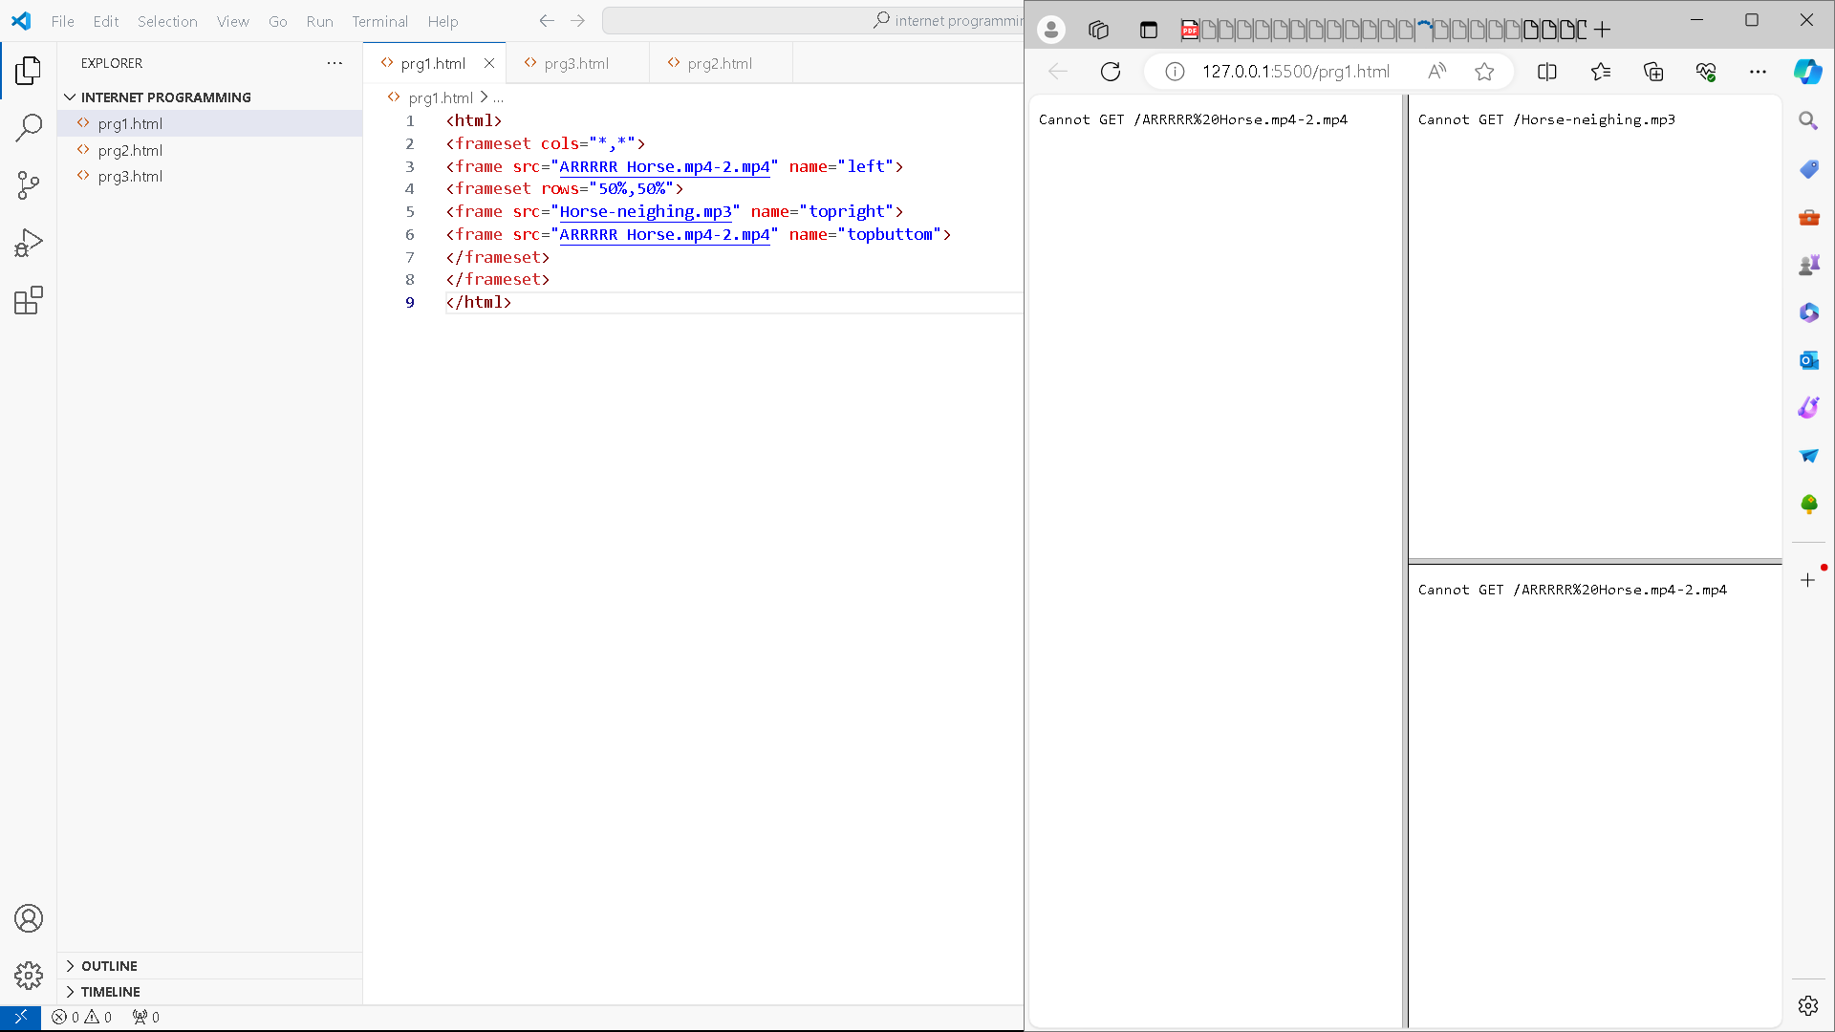

<html>

<frameset cols="*,*">

<frame src="ARRRRR Horse.mp4-2.mp4" name="left">

<frameset rows="50%,50%">

<frame src="Horse-neighing.mp3" name="topright">

<frame src="ARRRRR Horse.mp4-2.mp4" name="topbuttom">

</frameset>

</frameset>

</html>

16. Create a web page using Embedded CSS

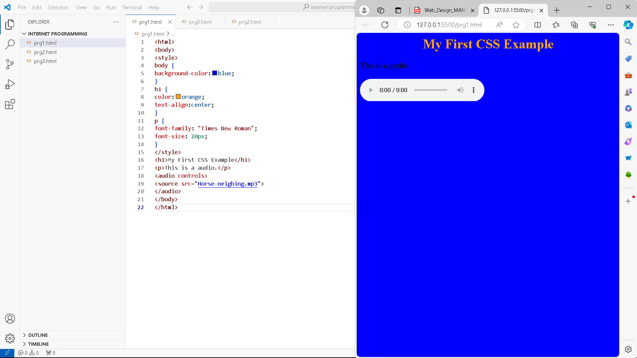

<html>

<body>

<style>

body {

background-color:blue;

}

h1 {

color:orange;

text-align:center;

}

p {

font-family: "Times New Roman";

font-size: 20px;

}

</style>

<h1>My First CSS Example</h1>

<p>This is a audio.</p>

<audio controls>

<source src="Horse-neighing.mp3">

</audio>

</body>

</html>

17. Use tables to provide layout to your HTML page describing your college infrastructure.

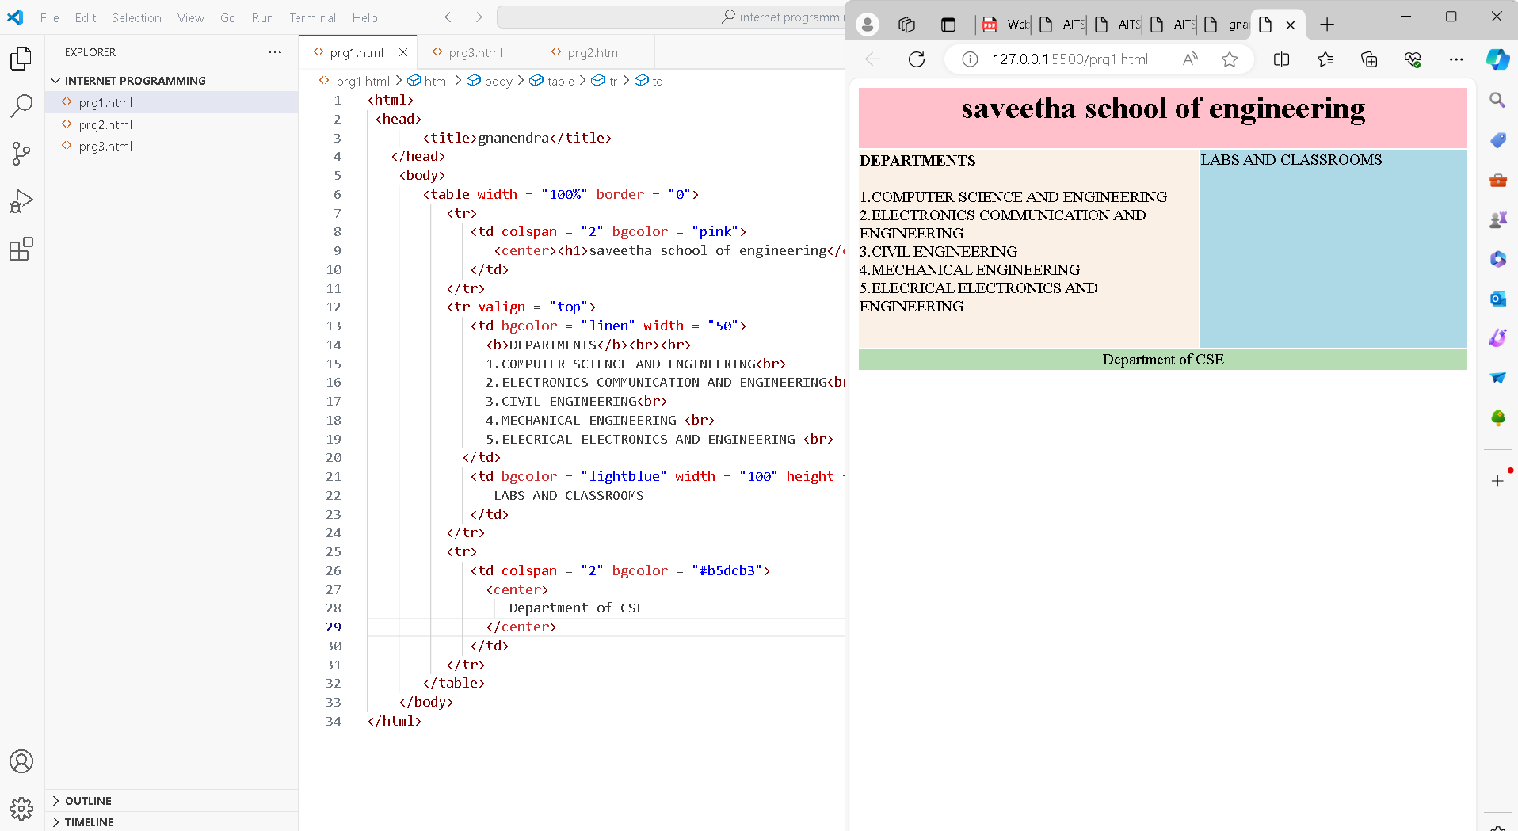

<html>

 <head>

       <title>gnanendra</title>

   </head>

    <body>

       <table width = "100%" border = "0">

          <tr>

             <td colspan = "2" bgcolor = "pink">

                <center><h1>saveetha school of engineering</center></h1>

             </td>

          </tr>

          <tr valign = "top">

             <td bgcolor = "linen" width = "50">

               <b>DEPARTMENTS</b><br><br>

               1.COMPUTER SCIENCE AND ENGINEERING<br>

               2.ELECTRONICS COMMUNICATION AND ENGINEERING<br>

               3.CIVIL ENGINEERING<br>

               4.MECHANICAL ENGINEERING <br>

               5.ELECRICAL ELECTRONICS AND ENGINEERING <br>

            </td>

             <td bgcolor = "lightblue" width = "100" height = "200">

                LABS AND CLASSROOMS

             </td>

          </tr>

          <tr>

             <td colspan = "2" bgcolor = "#b5dcb3">

               <center>

                  Department of CSE

               </center>

             </td>

          </tr>

       </table>

    </body>

</html>

18. Use and

tags to provide a layout to the above page instead of a table layout.

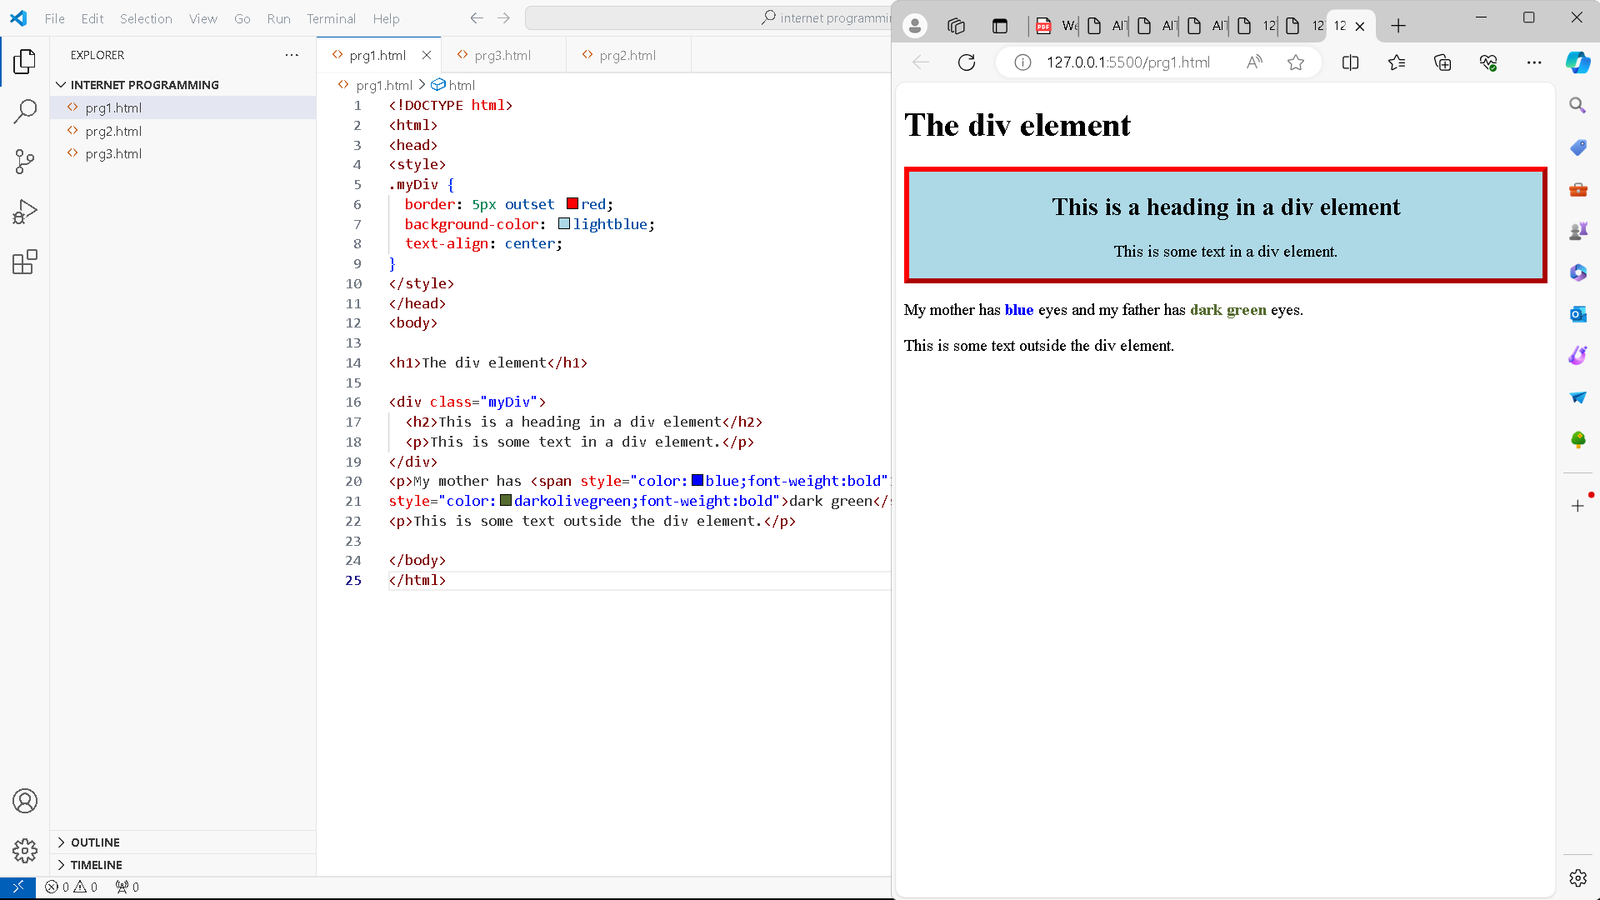

<!DOCTYPE html>

<html>

<head>

<style>

.myDiv {

  border: 5px outset red;

  background-color: lightblue;

  text-align: center;

}

</style>

</head>

<body>

<h1>The div element</h1>

<div class="myDiv">

  <h2>This is a heading in a div element</h2>

  <p>This is some text in a div element.</p>

</div>

<p>My mother has <span style="color:blue;font-weight:bold">blue</span> eyes and my father has <span

style="color:darkolivegreen;font-weight:bold">dark green</span> eyes.</p>

<p>This is some text outside the div element.</p>

</body>

</html>

19. Use frames such that page is divided into 3 frames 20% on left to show contents of pages, 60% in center to show body of page, remaining on right to show remarks.

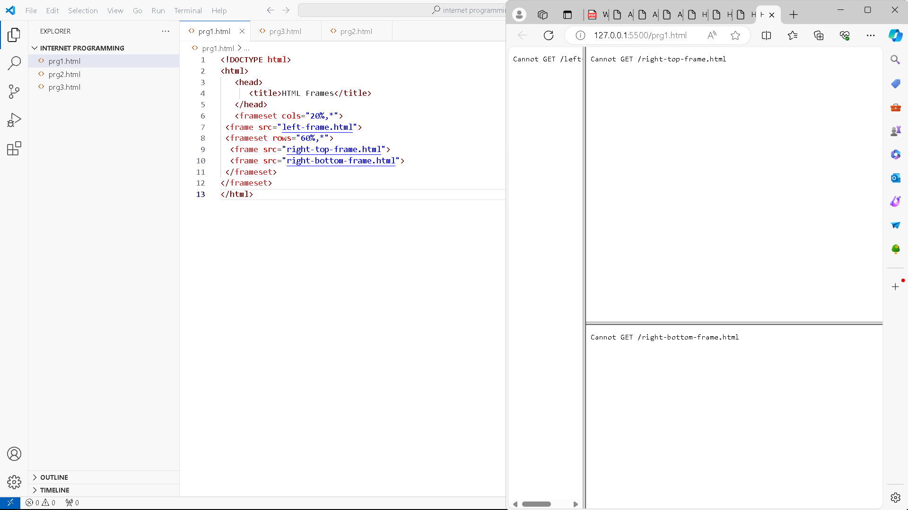

<!DOCTYPE html>

<html>

   <head>

      <title>HTML Frames</title>

   </head>

   <frameset cols="20%,*">

 <frame src="left-frame.html">

 <frameset rows="60%,*">

  <frame src="right-top-frame.html">

  <frame src="right-bottom-frame.html">

 </frameset>

</frameset>

</html>

20. Embed Audio and Video into your HTML web page.

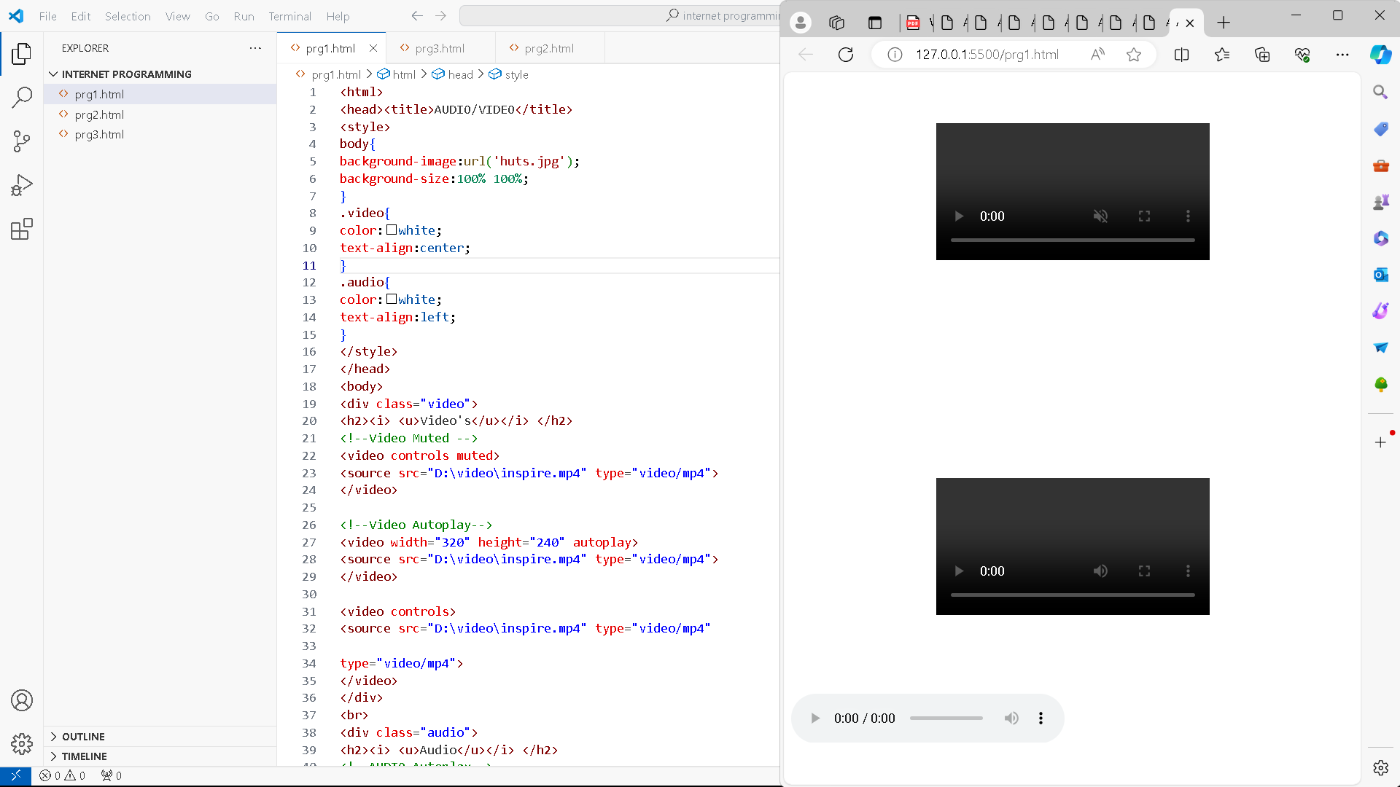

<html>

<head><title>AUDIO/VIDEO</title>

<style>

body{

background-image:url('huts.jpg');

background-size:100% 100%;

}

.video{

color:white;

text-align:center;

}

.audio{

color:white;

text-align:left;

}

</style>

</head>

<body>

<div class="video">

<h2><i> <u>Video's</u></i> </h2>

<!--Video Muted -->

<video controls muted>

<source src="D:\video\inspire.mp4" type="video/mp4">

</video>

<!--Video Autoplay-->

<video width="320" height="240" autoplay>

<source src="D:\video\inspire.mp4" type="video/mp4">

</video>

<video controls>

<source src="D:\video\inspire.mp4" type="video/mp4"

type="video/mp4">

</video>

</div>

<br>

<div class="audio">

<h2><i> <u>Audio</u></i> </h2>

<!--AUDIO Autoplay-->

<audio controls>

<source src="D:\my music\final.mp3"

type="audio/mp3">

</audio>

</div>

</body>

</html>

21. Create a webpage with HTML describing your department use paragraph and list tags.

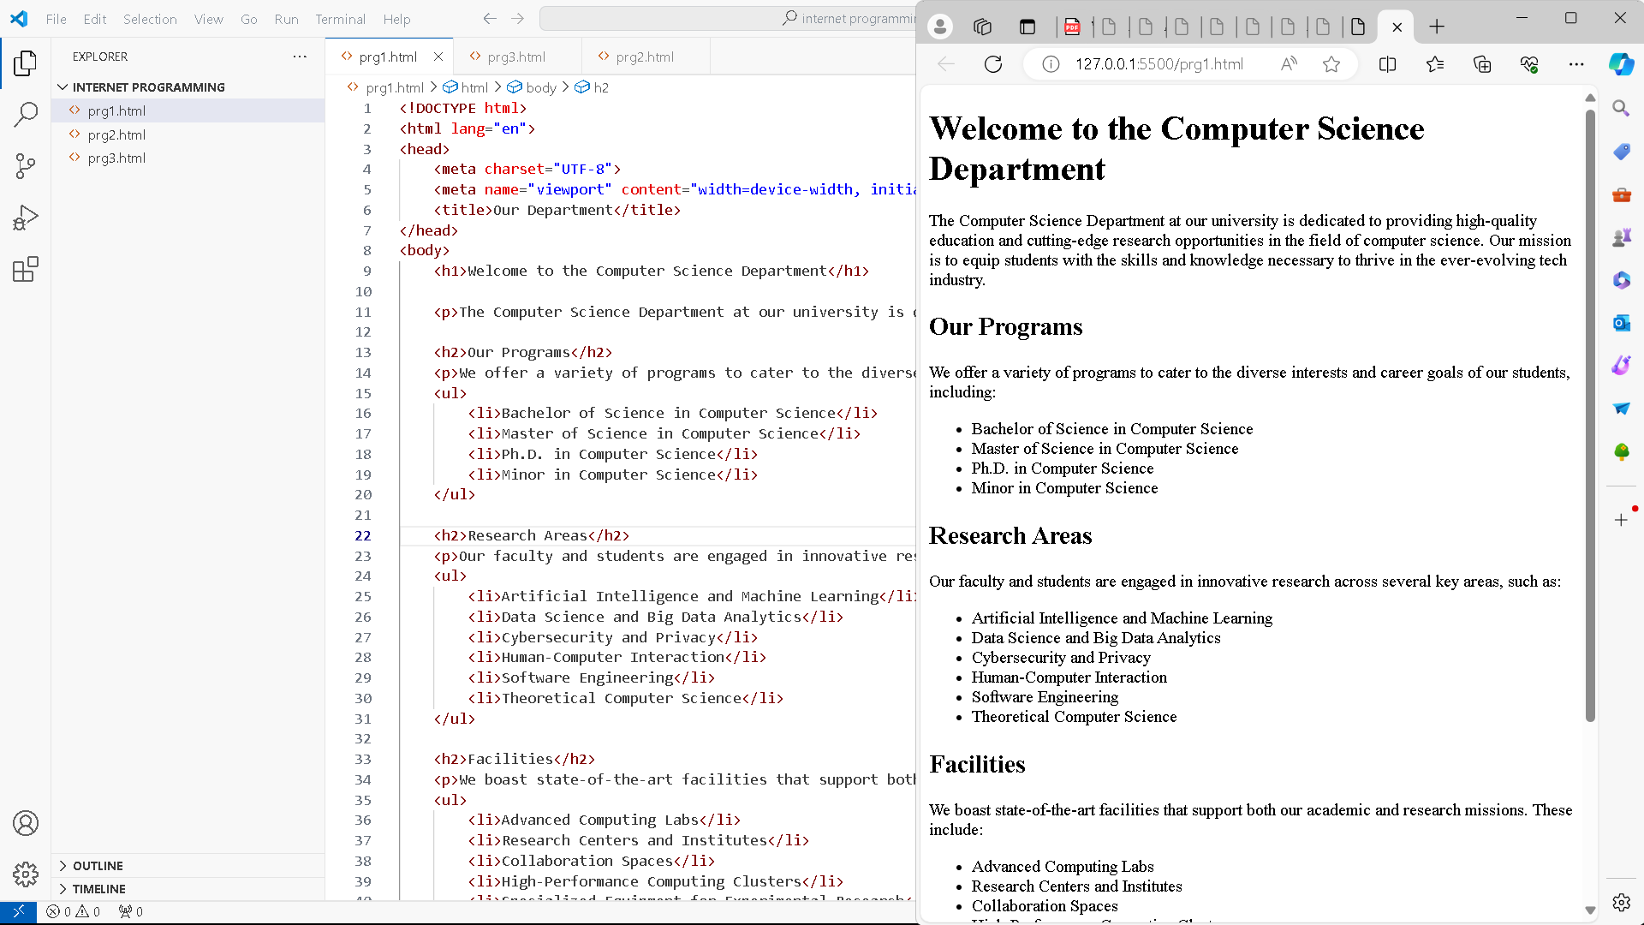

<!DOCTYPE html>

<html lang="en">

<head>

    <meta charset="UTF-8">

    <meta name="viewport" content="width=device-width, initial-scale=1.0">

    <title>Our Department</title>

</head>

<body>

    <h1>Welcome to the Computer Science Department</h1>

    <p>The Computer Science Department at our university is dedicated to providing high-quality education and cutting-edge research opportunities in the field of computer science. Our mission is to equip students with the skills and knowledge necessary to thrive in the ever-evolving tech industry.</p>

    <h2>Our Programs</h2>

    <p>We offer a variety of programs to cater to the diverse interests and career goals of our students, including:</p>

    <ul>

        <li>Bachelor of Science in Computer Science</li>

        <li>Master of Science in Computer Science</li>

        <li>Ph.D. in Computer Science</li>

        <li>Minor in Computer Science</li>

    </ul>

    <h2>Research Areas</h2>

    <p>Our faculty and students are engaged in innovative research across several key areas, such as:</p>

    <ul>

        <li>Artificial Intelligence and Machine Learning</li>

        <li>Data Science and Big Data Analytics</li>

        <li>Cybersecurity and Privacy</li>

        <li>Human-Computer Interaction</li>

        <li>Software Engineering</li>

        <li>Theoretical Computer Science</li>

    </ul>

    <h2>Facilities</h2>

    <p>We boast state-of-the-art facilities that support both our academic and research missions. These include:</p>

    <ul>

        <li>Advanced Computing Labs</li>

        <li>Research Centers and Institutes</li>

        <li>Collaboration Spaces</li>

        <li>High-Performance Computing Clusters</li>

        <li>Specialized Equipment for Experimental Research</li>

    </ul>

    <h2>Contact Us</h2>

    <p>If you have any questions or would like more information about our department, please don't hesitate to get in touch:</p>

    <ul>

        <li>Email: csdepartment@university.edu</li>

        <li>Phone: (123) 456-7890</li>

        <li>Address: 123 University Ave, City, State, ZIP Code</li>

    </ul>

</body>

</html>

22. Apply various colors to suitably distinguish key words, also apply font styling like italics, underline and two other fonts to words you find appropriate, also use header tags.

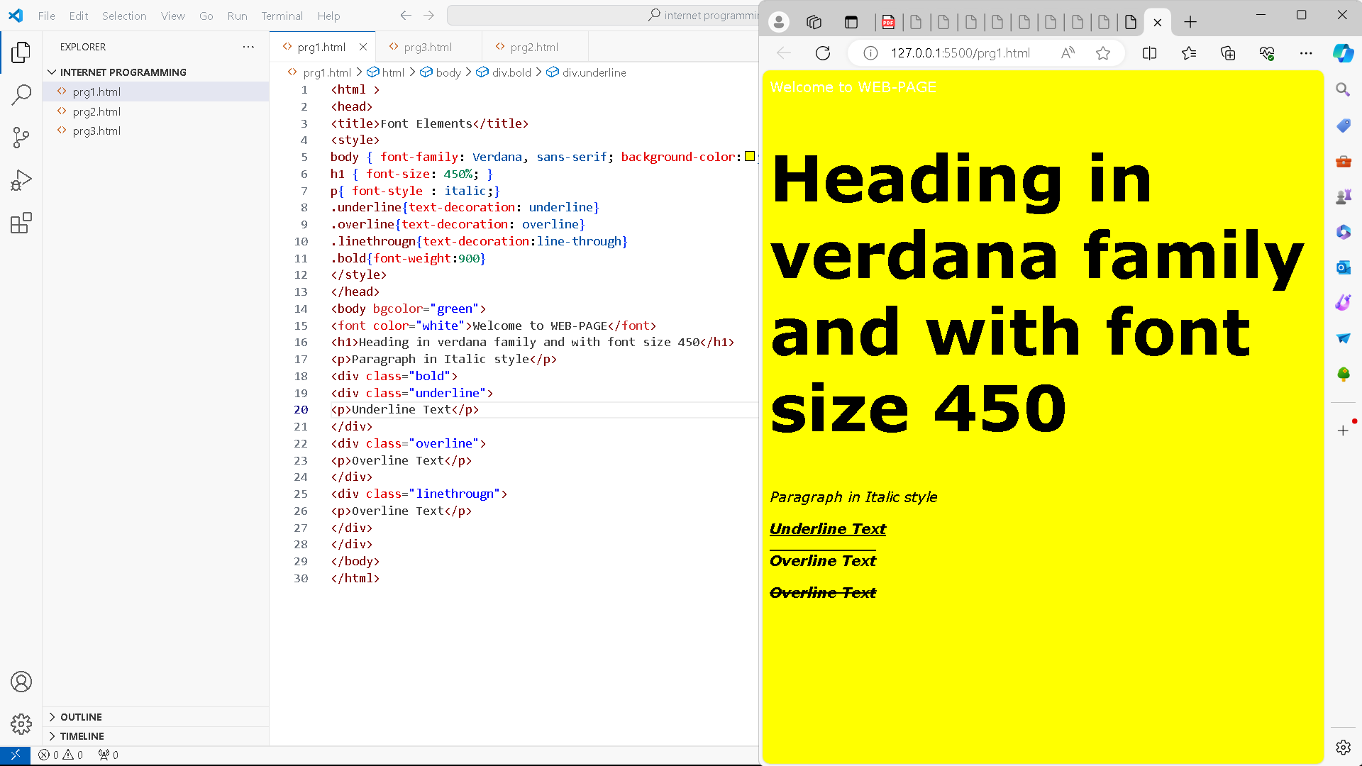

<html >

<head>

<title>Font Elements</title>

<style>

body { font-family: Verdana, sans-serif; background-color:yellow;}

h1 { font-size: 450%; }

p{ font-style : italic;}

.underline{text-decoration: underline}

.overline{text-decoration: overline}

.linethrougn{text-decoration:line-through}

.bold{font-weight:900}

</style>

</head>

<body bgcolor="green">

<font color="white">Welcome to WEB-PAGE</font>

<h1>Heading in verdana family and with font size 450</h1>

<p>Paragraph in Italic style</p>

<div class="bold">

<div class="underline">

<p>Underline Text</p>

</div>

<div class="overline">

<p>Overline Text</p>

</div>

<div class="linethrougn">

<p>Overline Text</p>

</div>

</div>

</body>

</html>

23. Create links on the words e.g. ―Wi-Fi and ―LAN‖ to link them to Wikipedia pages.

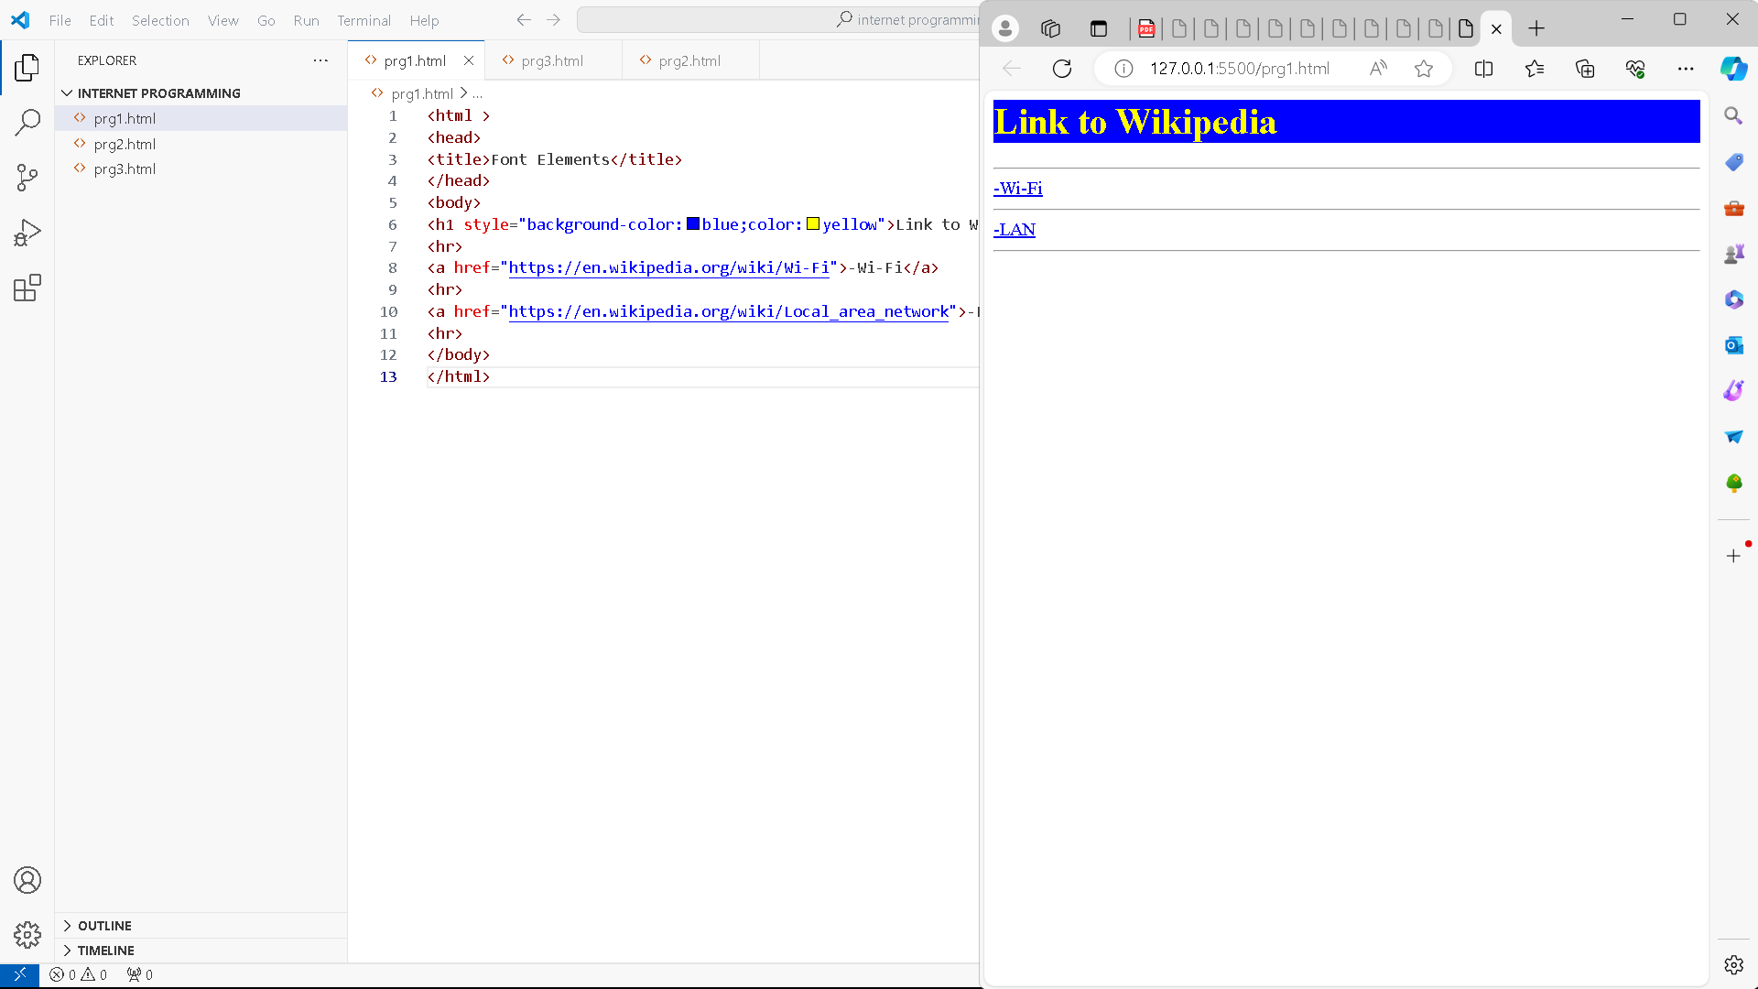

<html >

<head>

<title>Font Elements</title>

</head>

<body>

<h1 style="background-color:blue;color:yellow">Link to Wikipedia</h1>

<hr>

<a href="https://en.wikipedia.org/wiki/Wi-Fi">-Wi-Fi</a>

<hr>

<a href="https://en.wikipedia.org/wiki/Local_area_network">-LAN</a>

<hr>

</body>

</html>

24. Insert an image and create a link such that clicking on image takes user to other page.

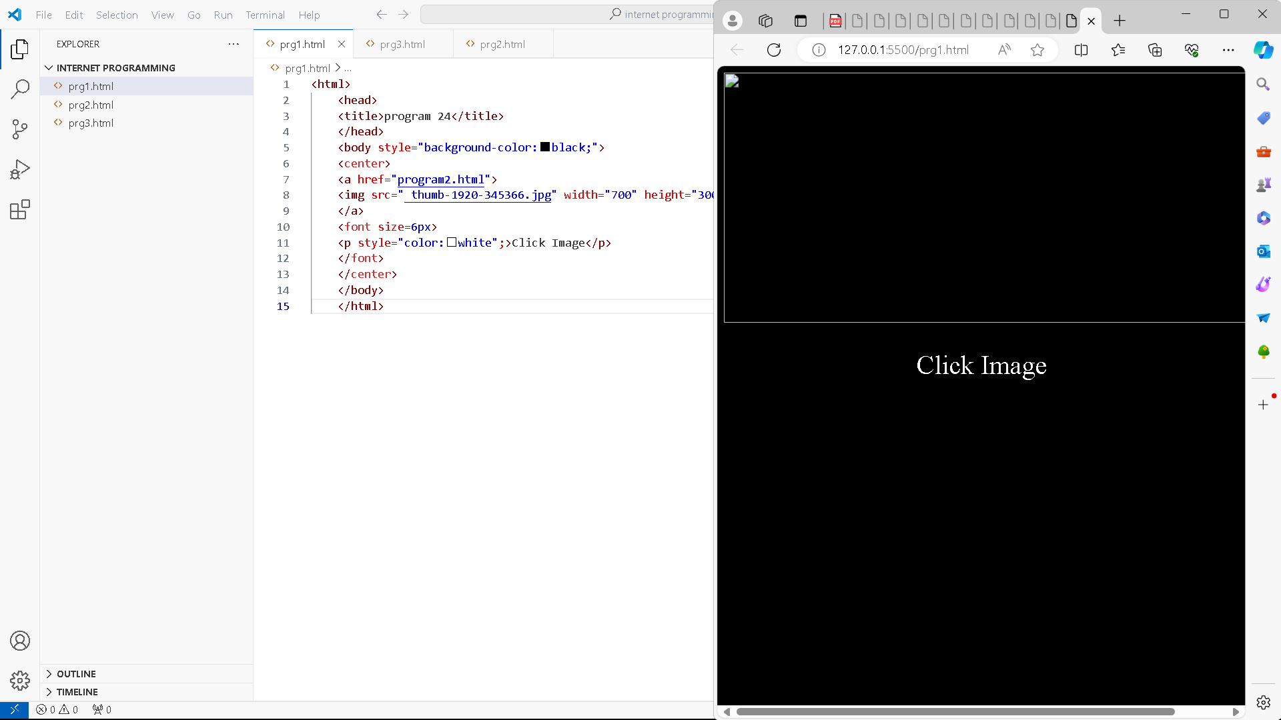

<html>

    <head>

    <title>program 24</title>

    </head>

    <body style="background-color:black;">

    <center>

    <a href="program2.html">

    <img src=" thumb-1920-345366.jpg" width="700" height="300"/>

    </a>

    <font size=6px>

    <p style="color:white";>Click Image</p>

    </font>

    </center>

    </body>

    </html>

25. Change the background color of the page; At the bottom create a link to take user to the top of the page.

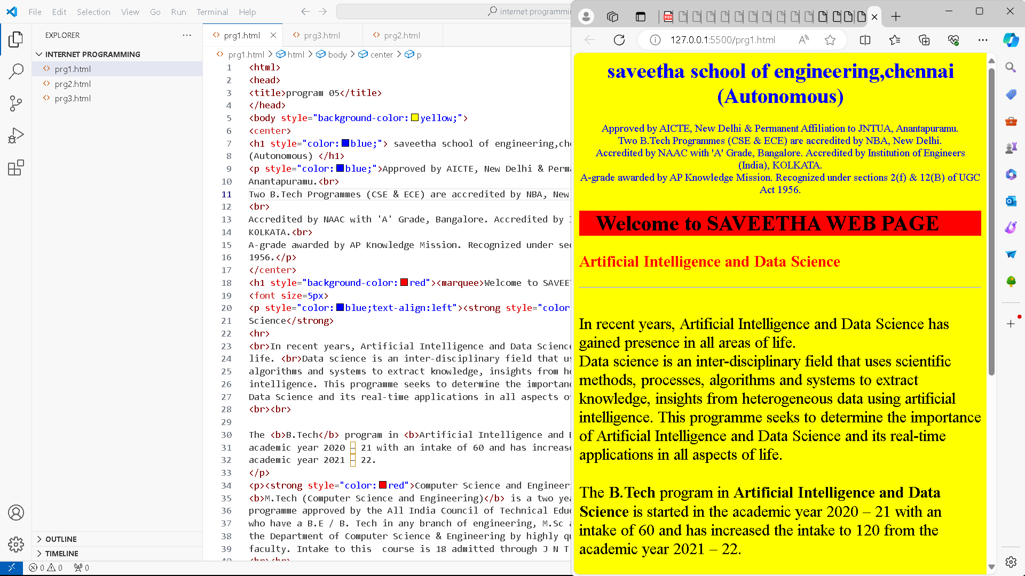

<html>

<head>

<title>program 05</title>

</head>

<body style="background-color:yellow;">

<center>

<h1 style="color:blue;"> saveetha school of engineering,chennai <br>

(Autonomous) </h1>

<p style="color:blue;">Approved by AICTE, New Delhi & Permanent Affiliation to JNTUA,

Anantapuramu.<br>

Two B.Tech Programmes (CSE & ECE) are accredited by NBA, New Delhi.

<br>

Accredited by NAAC with 'A' Grade, Bangalore. Accredited by Institution of Engineers (India),

KOLKATA.<br>

A-grade awarded by AP Knowledge Mission. Recognized under sections 2(f) & 12(B) of UGC Act

1956.</p>

</center>

<h1 style="background-color:red"><marquee>Welcome to SAVEETHA WEB PAGE</marquee></h1>

<font size=5px>

<p style="color:blue;text-align:left"><strong style="color:red">Artificial Intelligence and Data

Science</strong>

<hr>

<br>In recent years, Artificial Intelligence and Data Science has gained presence in all areas of

life. <br>Data science is an inter-disciplinary field that uses scientific methods, processes,

algorithms and systems to extract knowledge, insights from heterogeneous data using artificial

intelligence. This programme seeks to determine the importance of Artificial Intelligence and

Data Science and its real-time applications in all aspects of life.

<br><br>

The <b>B.Tech</b> program in <b>Artificial Intelligence and Data Science</b> is started in the

academic year 2020 – 21 with an intake of 60 and has increased the intake to 120 from the

academic year 2021 – 22.

</p>

<p><strong style="color:red">Computer Science and Engineering (CSE)</strong><hr>

<b>M.Tech (Computer Science and Engineering)</b> is a two year full time post-graduate

programme approved by the All India Council of Technical Education (AICTE) for the students

who have a B.E / B. Tech in any branch of engineering, M.Sc and M.C.A. The course is offered by

the Department of Computer Science & Engineering by highly qualified and experienced teaching

faculty. Intake to this  course is 18 admitted through J N T University’s.

<br><br>

The <b>B.Tech CSE </b>Programme was accredited by NBA first time  under tier – II in 2016

and further extension of accreditation in  granted up to June 2023.</p>

</font>

<h3><a href="#up">Click here to go UP</a></h3>

</body>

</html>

26. Develop static pages (using only HTML) of an online book store, the pages should resemble: www.amazon.com, the website should consist the following pages, home page, registration and user login, user profile page, books catalog, shopping cart, payment by credit card, order confirmation.

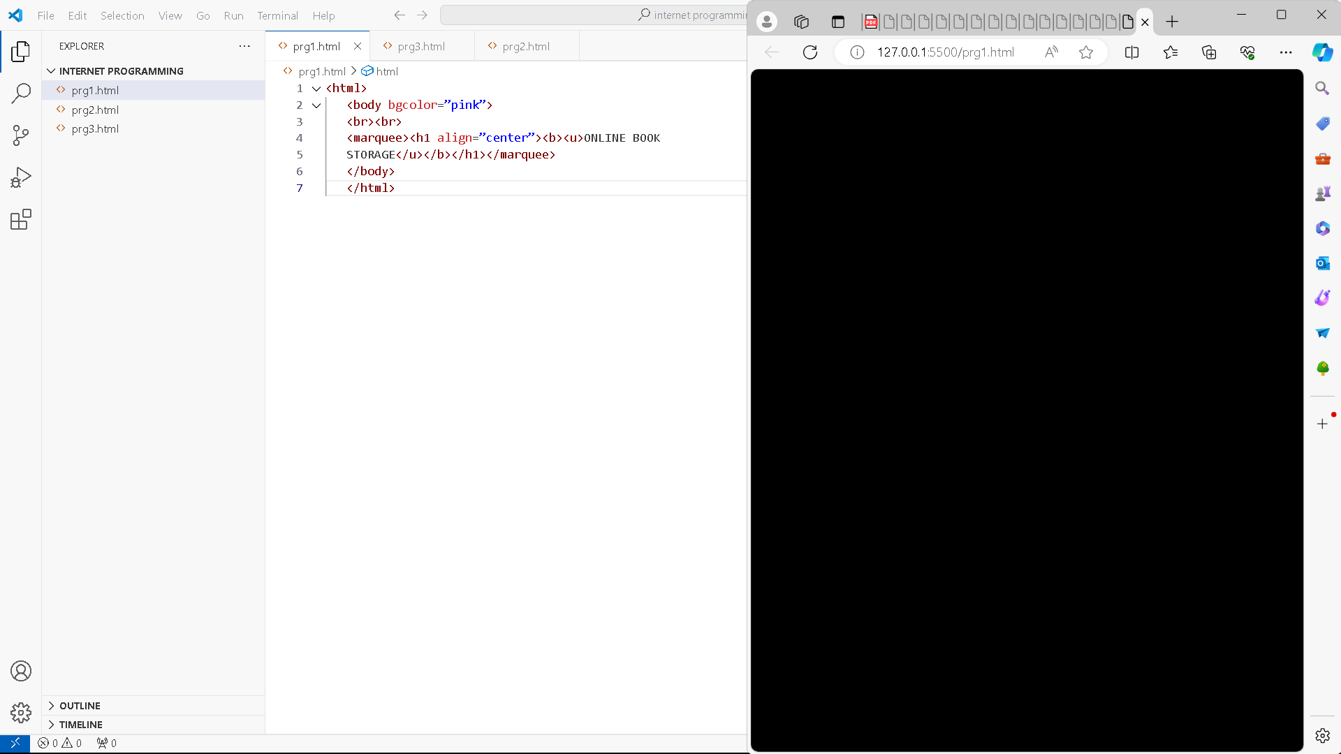

<html>

   <body bgcolor=”pink”>

   <br><br>

   <marquee><h1 align=”center”><b><u>ONLINE BOOK

   STORAGE</u></b></h1></marquee>

   </body>

   </html>

27. Create a table to show your class time table.

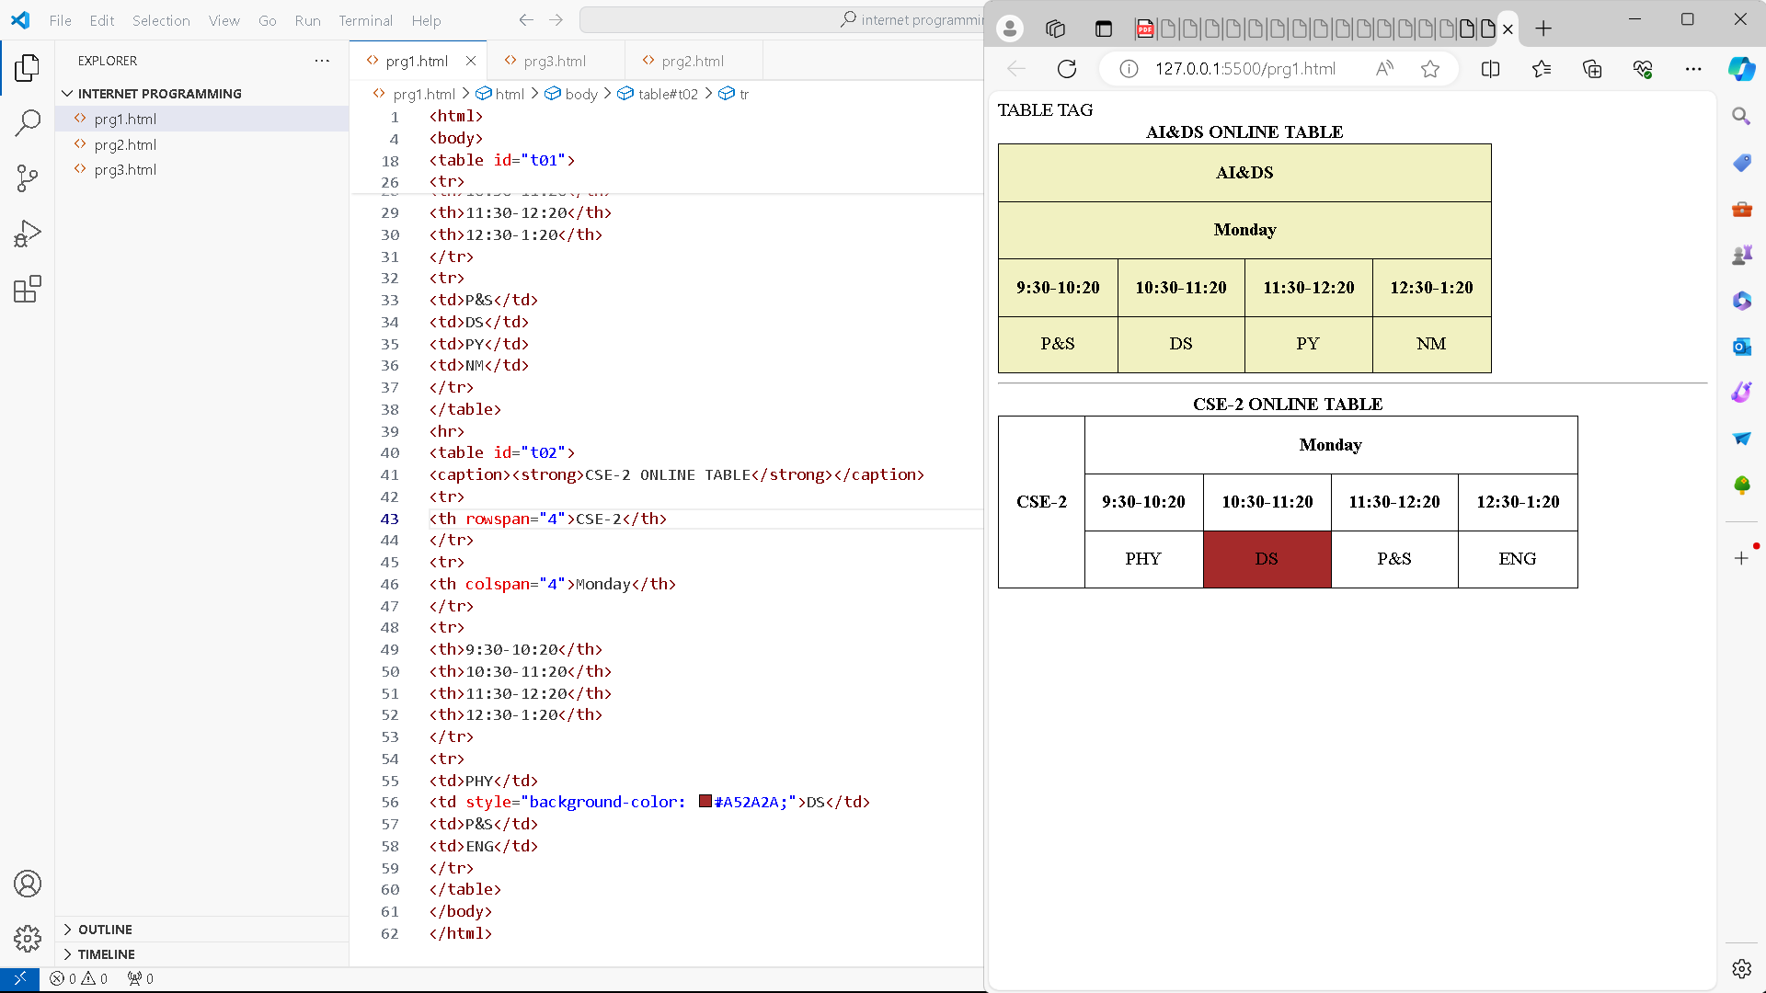

<html>

<head>TABLE TAG</head>

<title>TABLE</title>

<body>

<style>

table, th, td

{

border: 1px solid black;

border-collapse:collapse;

padding:15px;

}

#t01

{

background-color: #f1f1c1;

}

td{text-align:center;}

</style>

<table id="t01">

<caption><b>AI&DS ONLINE TABLE</b></caption>

<tr>

<th colspan="4">AI&DS</th>

</tr>

<tr>

<th colspan="4">Monday</th>

</tr>

<tr>

<th>9:30-10:20</th>

<th>10:30-11:20</th>

<th>11:30-12:20</th>

<th>12:30-1:20</th>

</tr>

<tr>

<td>P&S</td>

<td>DS</td>

<td>PY</td>

<td>NM</td>

</tr>

</table>

<hr>

<table id="t02">

<caption><strong>CSE-2 ONLINE TABLE</strong></caption>

<tr>

<th rowspan="4">CSE-2</th>

</tr>

<tr>

<th colspan="4">Monday</th>

</tr>

<tr>

<th>9:30-10:20</th>

<th>10:30-11:20</th>

<th>11:30-12:20</th>

<th>12:30-1:20</th>

</tr>

<tr>

<td>PHY</td>

<td style="background-color: #A52A2A;">DS</td>

<td>P&S</td>

<td>ENG</td>

</tr>

</table>

</body>

</html>

28. Write an HTML page that contains a selection box with a list of 5 countries, when the user selects a country, its capital should be printed next to the list; Add CSS to customize the properties of the font of the capital (color, bold and font size).

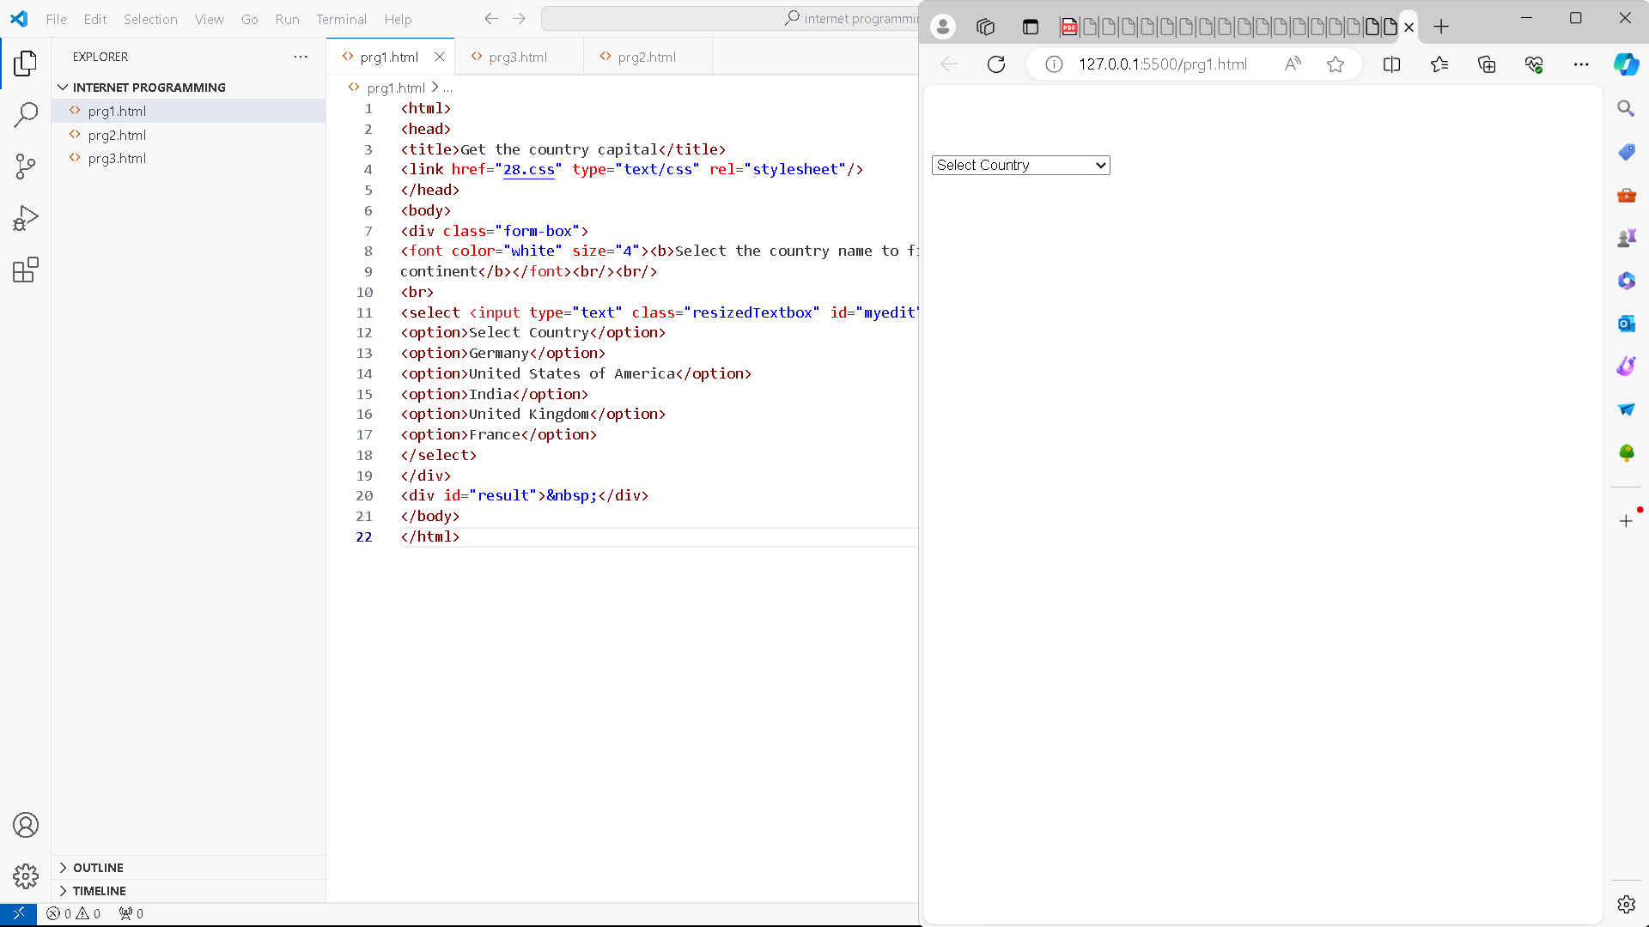

<html>

<head>

<title>Get the country capital</title>

<link href="28.css" type="text/css" rel="stylesheet"/>

</head>

<body>

<div class="form-box">

<font color="white" size="4"><b>Select the country name to find its capital and

continent</b></font><br/><br/>

<br>

<select <input type="text" class="resizedTextbox" id="myedit"/>>

<option>Select Country</option>

<option>Germany</option>

<option>United States of America</option>

<option>India</option>

<option>United Kingdom</option>

<option>France</option>

</select>

</div>

<div id="result">&nbsp;</div>

</body>

</html>

29. Wap in html to design a Bio-Data.

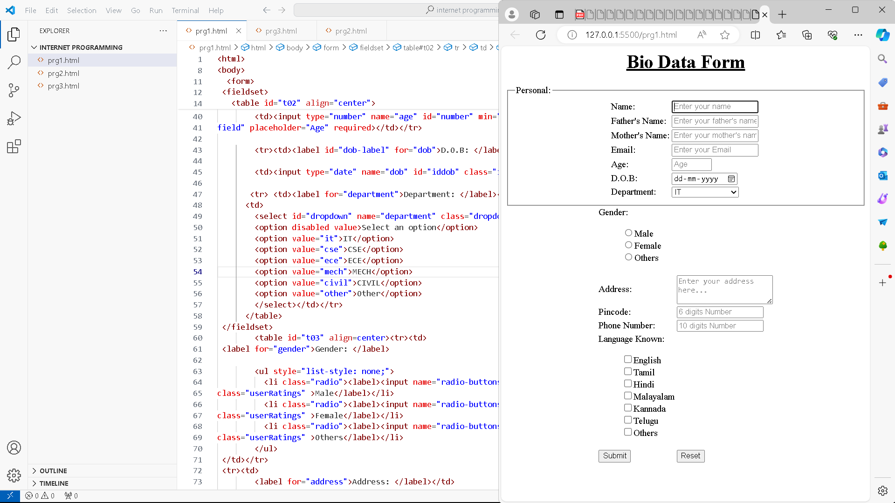

<html>

<head><title>Bio Data Form</title>

<style>

h1{text-align:center;

text-decoration: underline}

</style>

</head>

<body>

<h1>Bio Data Form</h1>

  <form>

 <fieldset>

  <legend>Personal:</legend>

   <table id="t02" align="center">

        <tr><td><label id="name-label" for="name">Name: </label></td>

        <td><input autofocus type="text" name="name" id="name" class="input-field"

placeholder="Enter your name" required></td></tr>

        <tr><td><label id="fname-label" for="fname">Father's Name: </label></td>

        <td><input autofocus type="text" name="fname" id="fname" class="input-field"

placeholder="Enter your father's name" required></td></tr>

        <tr><td><label id="mname-label" for="mname">Mother's Name: </label></td>

        <td><input autofocus type="text" name="mname" id="mname" class="input-field"

placeholder="Enter your mother's name" required></td></tr>

        <tr><td><label id="email-label" for="email">Email: </label></td>

        <td><input type="email" name="email" id="email" class="input-field" required

placeholder="Enter your Email"></td></tr>

        <tr><td><label id="number-label" for="age">Age: </label></td>

        <td><input type="number" name="age" id="number" min="1" max="125" class="input

field" placeholder="Age" required></td></tr>

        <tr><td><label id="dob-label" for="dob">D.O.B: </label></td>

        <td><input type="date" name="dob" id="iddob" class="input-field" required><td></tr>

       <tr> <td><label for="department">Department: </label></td>

      <td>

        <select id="dropdown" name="department" class="dropdown">

        <option disabled value>Select an option</option>

        <option value="it">IT</option>

        <option value="cse">CSE</option>

        <option value="ece">ECE</option>

        <option value="mech">MECH</option>

        <option value="civil">CIVIL</option>

        <option value="other">Other</option>

        </select></td></tr>

      </table>

 </fieldset>

        <table id="t03" align=center><tr><td>

 <label for="gender">Gender: </label>

        <ul style="list-style: none;">

          <li class="radio"><label><input name="radio-buttons" value="male"  type="radio"

class="userRatings" >Male</label></li>

          <li class="radio"><label><input name="radio-buttons" value="female"  type="radio"

class="userRatings" >Female</label></li>

          <li class="radio"><label><input name="radio-buttons" value="others"  type="radio"

class="userRatings" >Others</label></li>

        </ul>

 </td></tr>

 <tr><td>

        <label for="address">Address: </label></td>

        <td><textarea id="comments" class="input-field" style="height:50px;resize:vertical;"

name="address" placeholder="Enter your address here..."></textarea></td></tr>

        <tr><td><label for="pincode">Pincode: </label></td>

       <td><input type="number" name="pincode" id="idpincode" class="input-field"

style="height:20px;resize:vertical;" placeholder="6 digits Number"></td></tr>

    <tr><td><label for="pincode">Phone Number: </label></td>

       <td><input type="number" name="Phone Number" id="idphonenumber" class="input

field" style="height:20px;resize:vertical;" placeholder="10 digits Number"></td></tr>

        <tr><td><label for="language">Language Known: </label>

        <ul id="language" style="list-style: none;">

          <li class="checkbox"><label><input name="prefer" value="english" type="checkbox"

class="userRatings">English</label></li>

          <li class="checkbox"><label><input name="prefer" value="tamil" type="checkbox"

class="userRatings">Tamil</label></li>

          <li class="checkbox"><label><input name="prefer" value="hindi" type="checkbox"

class="userRatings">Hindi</label></li>

          <li class="checkbox"><label><input name="prefer" value="malayalam"

type="checkbox" class="userRatings">Malayalam</label></li>

          <li class="checkbox"><label><input name="prefer" value="kannada" type="checkbox"

class="userRatings">Kannada</label></li>

          <li class="checkbox"><label><input name="prefer" value="telugu" type="checkbox"

class="userRatings">Telugu</label></li>

          <li class="checkbox"><label><input name="prefer" value="others" type="checkbox"

class="userRatings">Others</label></li>

        </ul>

 </td></tr>

    <tr><td><button id="submit" type="submit">Submit</button></td><td>

    <button id="reset" type="reset">Reset</button></td></tr>

  </table>

</form>

</body>

</html>

30. Wap in html to create a webpage with four frames (Picture, table, list, and hyperlink).

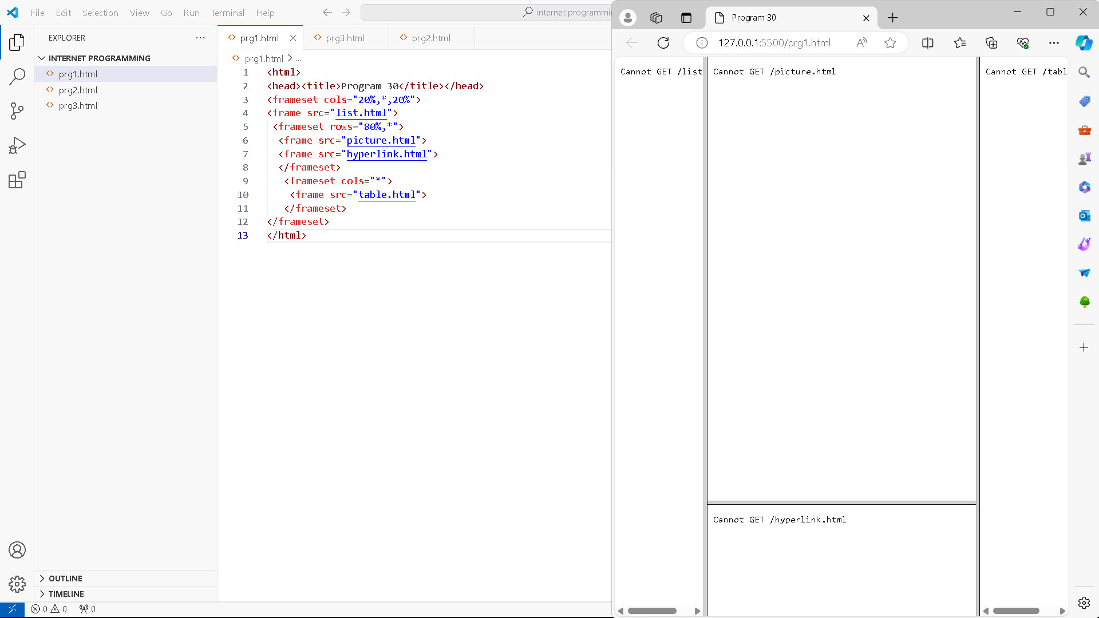

<html>

<head><title>Program 30</title></head>

<frameset cols="20%,*,20%">

<frame src="list.html">

 <frameset rows="80%,*">

  <frame src="picture.html">

  <frame src="hyperlink.html">

  </frameset>

   <frameset cols="*">

    <frame src="table.html">

   </frameset>

</frameset>

</html>